1. Theory of Computation (ToC)
The Theory of Computation is a branch of computer science and mathematics that studies the fundamental capabilities and limitations of computers. It deals with how efficiently problems can be solved using algorithms and computational models.

Major Areas of Theory of Computation
The field is primarily divided into three interrelated areas:
- Automata Theory
  - Definition: Automata Theory studies abstract mathematical models of computation, known as automata, and how they process input strings.
  - Example: A Finite State Machine (FSM) can model a vending machine that transitions between states based on user inputs (e.g., inserting coins, selecting products).
- Computability Theory
  - Definition: This area focuses on determining which problems can be solved by a computer and which cannot. It defines problems that are decidable (can be solved) and undecidable (cannot be solved).
  - Example: The Halting Problem, proved undecidable by Alan Turing, states that no algorithm can determine whether any given program will stop running or run forever.
- Complexity Theory
  - Definition: Complexity Theory studies the efficiency of algorithms by classifying problems based on their computational difficulty. It deals with different complexity classes like P, NP, NP-complete, and NP-hard.
  - Example: The Traveling Salesman Problem (TSP) is NP-hard, meaning there is no known efficient algorithm to find the shortest route among a set of cities.

Real-World Applications of Theory of Computation
- Compiler Design: Automata Theory is used in lexical analysis and syntax parsing.
- Artificial Intelligence: Computability and complexity theories help in optimizing AI algorithms.
- Cryptography: Complexity theory ensures secure encryption methods.
- Software Verification: Formal methods in ToC help verify the correctness of software.

2. Finite State Machine (FSM) / Finite Automata (FA)
A Finite State Machine (FSM) or Finite Automata (FA) is a mathematical model of computation that represents a system with a finite number of states. It processes a string of symbols (input) by transitioning between states according to a set of predefined rules.

Types of Finite Automata
Finite Automata are classified into two main types:
- Deterministic Finite Automaton (DFA)
  - Definition: In a DFA, for each state and input symbol, there is exactly one possible next state.
  - Example: Consider a DFA that accepts binary strings ending in 01:
States: {q0, q1, q2}
Alphabet: {0,1}
Transitions:
    - q0 → 0 → q1
    - q0 → 1 → q0
    - q1 → 1 → q2 (accepting state)
    - q1 → 0 → q1
    - q2 → 0,1 → q3 (dead state / trap state)
  - Use Case: DFA is used in lexical analyzers for token recognition in programming languages.
- Nondeterministic Finite Automaton (NFA)
  - Definition: In an NFA, a state can have multiple possible transitions for the same input or even move to a new state without consuming any input (ε-transitions).
  - Example: Consider an NFA that accepts strings ending in ab:
    - It has multiple paths to reach the accepting state.
    - It can move to a new state without reading an input (ε-transition).
  - Use Case: NFA is used in regular expression processing in text search and pattern matching.

Key Components of a Finite Automaton
A Finite Automaton is formally represented as a 5-tuple:
FA = (Q, Σ, δ, q0, F)
where:
- Q = Finite set of states
- Σ = Finite set of input symbols (alphabet)
- δ (delta) = Transition function (rules defining state changes)
- q0 = Start state
- F = Set of accepting (final) states

Real-World Applications of FSM
- Traffic Light System: Transitions between states (Red → Green → Yellow → Red).
- Vending Machines: FSM controls the product selection and payment process.
- Chatbots: FSM helps manage conversational flows.
- Network Protocols: Used in TCP/IP, HTTP request-response cycles.

3. Deterministic Finite Automaton (DFA) – Breakdown of Terminology
A Deterministic Finite Automaton (DFA) is a type of finite state machine used in automata theory and formal language processing. The term Deterministic Finite Automaton can be broken down into three key components:
Term | Meaning
Deterministic | Every input has exactly one possible transition for each state (i.e., no randomness or multiple choices).
Finite | The number of states in the automaton is finite (not infinite).
Automaton | A mathematical model of a machine that reads an input string and changes states based on transition rules.

4. Token in Compiler Design

Definition
A token is the smallest meaningful unit in a source code, recognized by the lexical analyzer (lexer/scanner) during the compilation process. It represents a single entity, such as a keyword, identifier, operator, or punctuation mark.

Example
Consider the following C statement:
c
CopyEdit
int sum = a + b;

The tokens in this statement are:
Token | Type
int | Keyword
sum | Identifier
= | Assignment Operator
a | Identifier
+ | Arithmetic Operator
b | Identifier
; | Separator (Semicolon)

Types of Tokens
Tokens are categorized into different types:

1️⃣ Keywords
- Reserved words in a programming language.
- Example: if, else, while, return, int, float.

2️⃣ Identifiers
- User-defined names for variables, functions, arrays, etc.
- Example: sum, count, totalValue.

3️⃣ Operators
- Symbols used to perform operations.
- Example: + (addition), - (subtraction), * (multiplication), == (comparison).

4️⃣ Literals (Constants)
- Fixed values directly written in the code.
- Example: 100 (integer constant), 3.14 (floating-point constant), "Hello" (string constant).

5️⃣ Punctuation (Separators)
- Special characters used to structure the code.
- Example: { } (braces), ( ) (parentheses), ; (semicolon), , (comma).

6️⃣ Special Symbols
- Symbols used in specific contexts.
- Example: @, #, $ in some languages.

Role of Tokens in Compilation
- Lexical Analysis
  - The lexer (first phase of a compiler) scans the source code and converts it into tokens.
- Syntax Analysis (Parsing)
  - The parser takes tokens as input and checks for grammatical correctness.
- Semantic Analysis
  - Ensures logical correctness (e.g., variable types match in operations).

Example: Tokenization Process
Consider the Python statement:
python
CopyEdit
x = 10 + 20

It is broken down into tokens as:
Token | Type
x | Identifier
= | Assignment Operator
10 | Integer Literal
+ | Arithmetic Operator
20 | Integer Literal

Conclusion
- Tokens are fundamental units in source code.
- They help the compiler break down and analyze code efficiently.
- Understanding tokens is crucial for writing compilers, interpreters, and lexical analyzers.

5. Difference Between Finite Automata With and Without Output
Finite automata can be classified into two broad categories:
- Finite Automata With Output → Produces an output based on states or transitions.
- Finite Automata Without Output → Accepts or rejects a string but does not produce an explicit output.

1️⃣ Finite Automata Without Output
These automata only decide whether an input string is accepted or rejected. They do not generate any output other than "Accepted" or "Rejected."

Types of Finite Automata Without Output
Type | Description
Deterministic Finite Automaton (DFA) | Every input has a unique transition from a state.
Nondeterministic Finite Automaton (NFA) | A state can have multiple transitions for the same input.
Epsilon-NFA (ε-NFA) | Allows transitions without consuming any input (ε-transitions).

2️⃣ Finite Automata With Output
These automata generate an output based on the input string and transitions.

Types of Finite Automata With Output
Type | Description
Moore Machine | Output depends only on the state.
Mealy Machine | Output depends on both the state and the input symbol.

Moore Machine (Output Depends on State)
- The output is associated with each state.
- Each state has a fixed output, irrespective of input.

Example: Moore Machine for Binary Parity Checking
If the input has an even number of 1’s, output 0; otherwise, output 1.
Current State | Input 0 | Input 1 | Output
q0 (Even 1’s) | q0 | q1 | 0
q1 (Odd 1’s) | q1 | q0 | 1

6. Why is it Called the Kleene Star in A*?
The Kleene Star (*) is named after the American mathematician Stephen Kleene, who introduced it as part of regular expressions and formal language theory. It represents zero or more repetitions of a given set of symbols.

1️⃣ Definition of Kleene Star
For any alphabet A, the Kleene Star notation A* represents the set of all possible strings (including the empty string) that can be formed using symbols from A.

Mathematical Definition
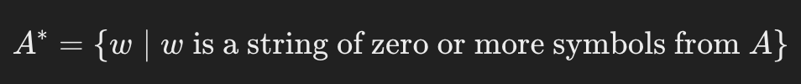
where www is any concatenation of elements from AAA, including the empty string ϵ\epsilonϵ.

2️⃣ Example of Kleene Star
Let A = {a, b}. Then:
This includes:
- The empty string ε
- All possible single-character strings: {a, b}
- All possible multi-character strings: {aa, ab, ba, bb, ...}

3️⃣ Difference Between Kleene Star and Kleene Plus
There is also the Kleene Plus (+), which is similar but excludes the empty string.
Operator | Definition | Example (for A = {a, b})
Kleene Star (A)* | 0 or more repetitions | {ε, a, b, aa, ab, ba, bb, ...}
Kleene Plus (A⁺) | 1 or more repetitions | {a, b, aa, ab, ba, bb, ...} (no ε)

Example: Regular Expressions
- (a|b)* → Matches any string of as and bs (including empty).
- (a|b)+ → Matches any string of as and bs (excluding empty).

4️⃣ Why is it Named After Kleene?
- Stephen Kleene was a pioneer in computability theory and automata theory.
- He introduced regular expressions and their connection to finite automata.
- The Kleene Star is a key part of defining regular languages.

5️⃣ Kleene Star in Automata
- DFA & NFA: The Kleene Star allows an automaton to recognize infinitely many strings without requiring infinite states.
- Example: A DFA for (0|1)* accepts any binary string (ε, 0, 1, 00, 01, 10, 11, ...).

🔹 Conclusion
The Kleene Star (*) is named after Stephen Kleene and is a fundamental operation in formal languages and regular expressions, allowing us to express repetition compactly.
Would you like a DFA example for a Kleene Star language like (0|1)*?
7. DFA without a dead or trap state:
A DFA can exist without a dead or trap state; this simply means that for every possible state and input symbol, there is a defined transition to another state, including the possibility of transitioning to an accepting state, effectively eliminating the need for a "dead" state where no further transitions are possible.
Key points to remember:
Definition of a dead state: A dead state is a state where no matter what input symbol is read, it always transitions to itself (or another non-accepting state), essentially trapping the DFA in a non-accepting condition.
Complete DFA: A DFA where every state has a defined transition for every possible input symbol is considered a "complete" DFA.
Designing without a dead state: To design a DFA without a dead state, ensure that every possible transition from any state is defined and leads to another reachable state, including accepting states if the input string should be accepted in that scenario.

8. Definition of n-Equivalence in Finite Automata
Two states A and B in a finite automaton are said to be n-equivalent if they behave identically for all input strings of length up to n.

This means that if we start in either state AAA or BBB and process any input string of length at most nnn, both states must either always lead to a final state or never lead to a final state.

📌 Cases of n-Equivalence

1️⃣ 0-Equivalence (A≡0BA \equiv_0 BA≡0​B)
- Two states are 0-equivalent if they are either both final or both non-final.
- We do not consider any input strings, only whether the states themselves are final.
✅ Example:
Consider a DFA with states q0, q1, q2 and final states F={q2}F = \{q2\}F={q2}.
State | Final?
q0 | ❌ No
q1 | ❌ No
q2 | ✅ Yes
- q0≡0q1q0 \equiv_0 q1q0≡0​q1 (both are non-final).
- q0̸≡0q2q0 \not\equiv_0 q2q0≡0​q2 (q0 is non-final, q2 is final).

2️⃣ 1-Equivalence (A≡1BA \equiv_1 BA≡1​B)
- Two states are 1-equivalent if for every input symbol a∈Σa \in \Sigmaa∈Σ, their transitions lead to states that are 0-equivalent.
✅ Example:
Consider the following DFA transition table:
State | Input a | Input b | Final?
q0 | q1 | q2 | ❌ No
q1 | q1 | q2 | ❌ No
q2 | q2 | q2 | ✅ Yes
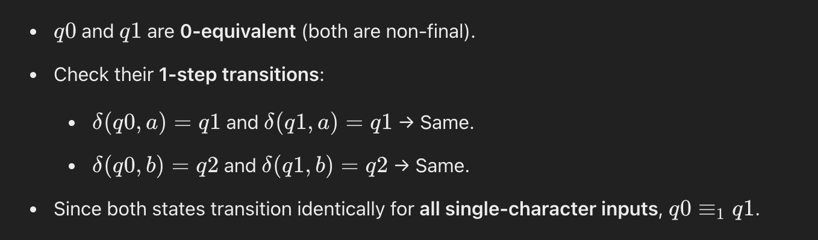
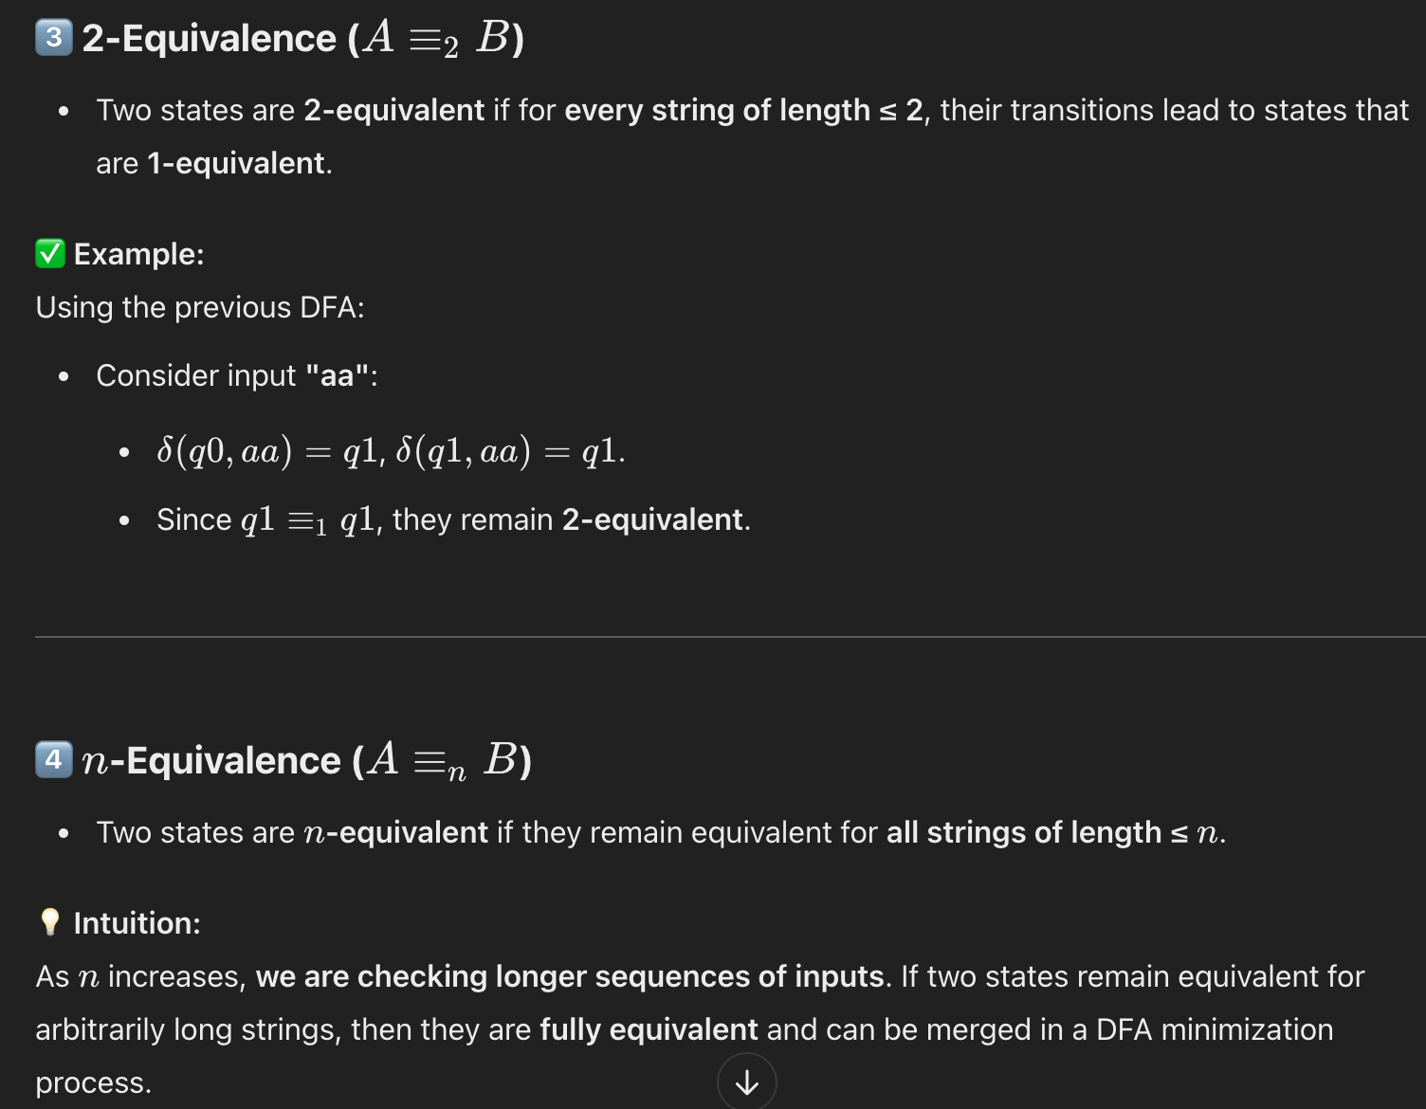

🔹 DFA Minimization Using n-Equivalence
- We use nnn-equivalence to identify and merge equivalent states, reducing the DFA’s size while preserving its language.
- The Myhill-Nerode Theorem formalizes this concept: states are equivalent if and only if they belong to the same equivalence class of indistinguishable strings.
Would you like a step-by-step example of DFA minimization using this concept? 🚀

